Scrivener’s Snapshots feature keeps older versions of your documents around for reference. To capture a version before embarking on a major edit of a document, select <$Scr_Cs::0>Take Snapshot<!$Scr_Cs::0> (<$Scr_Cs::0>Ctrl+5<!$Scr_Cs::0>) in the <$Scr_Cs::0>Documents > Snapshots<!$Scr_Cs::0> menu. Try that now (you will hear the sound of a camera shutter which indicates that the snapshot has been taken).
Once you have taken a snapshot, you can edit your document safe in the knowledge that you can return to the older version whenever you want.
Click on the “Snapshots” button (the one with the picture of a camera on it) in the inspector header bar to see what I mean.
<$Scr_Ps::1>• The inspector now shows a list of snapshots at the top, which should consist of the one you took and one I took while writing the first version of this tutorial.
• Clicking on a snapshot in the list reveals its text in the lower part of the inspector.
• Restore an older version of your text by selecting the version you want from the list and clicking on <$Scr_Cs::0>Roll Back<!$Scr_Cs::0> at the top (at which point, you will be given the option of taking another snapshot of your current version).<!$Scr_Ps::1><$Scr_Ps::2>
<$Scr_Cs::3>Note<!$Scr_Cs::3>: You can immediately tell which documents have snapshots associated with them because their icons have dog-eared corners. <!$Scr_Ps::2>
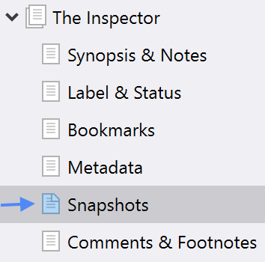
To see what’s changed in the document since the snapshot was taken, click on “Compare”. Try that now:
Type some text on the line below (anything you want):

Delete the text in the following line:
DELETE ME!
Now:
<$Scr_Ps::1>• In the inspector, select the snapshot you took a moment ago.
• Click “Compare”. See what happens?<!$Scr_Ps::1><$Scr_Ps::4>
⁃ Text that has been added to the document since the snapshot was taken appears underlined and in blue.
⁃ Text that has been deleted appears struck out and in red.
⁃ Note that the comparison only shows textual changes—it does not show changes to the formatting.<!$Scr_Ps::4><$Scr_Ps::1>
• Click on the left and right arrows at the top of the inspector, next to the three dots button, to navigate between the changes.<!$Scr_Ps::1><$Scr_Ps::2>
<$Scr_Cs::3>Tip<!$Scr_Cs::3>: You can alter the granularity (level of detail) of the comparison by clicking on the three dots button next to “Compare” (which should now read “Original”, because clicking on it again will turn off the compare feature). Changing the granularity will give different results for different documents, depending on the scope of the edits. <!$Scr_Ps::2>
You can also compare the differences between snapshots by selecting a snapshot in the list and clicking on <$Scr_Cs::0>Compare <!$Scr_Cs::0>to reveal the subsequent changes made after the selected snapshot was taken.
Let’s move on to “Comments & Footnotes”.

